PAUL EBERHART
Active QR Code →  Call/Text: (915) 777-9229  Website: www.pauleberhart.com  Email: pauleberhart@outlook.com  Address: 11325 Bullseye St. El Paso, TX 79934  Objective  Searching for an entry to mid-level tech position that highlights individual problem solving skills while working as an effective member of an efficient team.  Profile  Upon honorable medical discharge from the United States Army in 2014, Paul Eberhart participated in the US Department of Veterans Affairs Vocational Rehabilitation and Employment Program to professionally retrain his skillset into the Information Technology field. From spring 2015 through spring 2017, Paul earned an Associates of Science degree and achieved several industry-wide certifications.  Professional IT Merits  - AAS in Information Systems and Security from Western Tech (2017).  - Cisco Networking Academy CCNA Routing and Switching Course Completion Certificates (2016).  - CompTIA A+, CompTIA Security+, and CompTIA Linux+ Certified.  - Linux Professional Institute LPIC-1 Certified.  Other Professional Merits  - BA in Spanish with Honors from UNC Chapel Hill (2001).  - Decorated Operation Iraqi Freedom Combat Veteran (2009).  Other Unique Work Experiences  - Coordinated a soup kitchen for the Inter-Faith Council for Social Service (2005-2008).  - Developed the Spanish Language Lawyer Referral Service for the North Carolina Bar Foundation (2004).  - Worked as a call center representative for the American Social Health Association (2003-2005).  - Studied abroad at the prestigious Tec de Monterrey in Cuernavaca, Mexico (2000-2001). | 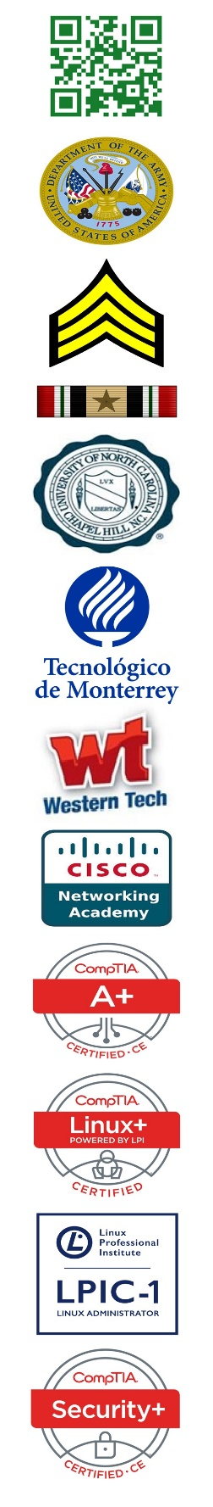
*** Military Record (DD-214), Prior Employment Contact Information, and References upon Request ***
* Logo usage above, authorized or otherwise, deemed “fair use” for informational purposes to represent Paul’s actual experiences *

